SULIT

UNIT PENGURUSAN AKADEMIK
UNIT BAHASA
PEJABAT PENDIDIKAN DAERAH KUDAT

PEPERIKSAAN PERCUBAAN SPM 2018 1119/2
BAHASA INGGERIS
Kertas 2
Ogos

2 ¼ jam Satu jam empat puluh lima minit

_____________________________________________________________

JANGAN BUKA KERTAS PEPERIKSAAN INI SEHINGGA DIBERITAHU

Arahan
1. Kertas soalan ini mengandungi empat bahagian : Bahagian A, Bahagian B, Bahagian C dan Bahagian D.
2. Jawab semua bahagian dalam kertas soalan ini.
3. Soalan-soalan dalam Bahagian A mempunyai empat pilihan jawapan. Jawab setiap soalan dengan menghitamkan ruang yang betul.
4. Jawapan anda hendaklah ditulis dalam buku jawapan yang disediakan. Sekiranya ruang jawapan tidak mencukupi, sila dapatkan helaian tambahan daripada pengawas peperiksaan.

Instructions
1. This question paper consists of four sections : Section A, Section B, Section C and Section D.
2. Answer all sections.
3. Questions in Section A have four options. Answer each question by blackening the correct space.
4. Your answer must be written in the answer sheets provided. If spaces in the sheets are insufficient, please request for additional answer sheets from the invigilator.

Kertas peperiksaan ini mengandungi 17 halaman bercetak
[Lihat halaman sebelah
1119/2 © 2018 SULIT

Section A
[15 marks]
[Time suggested : 25 minutes]

Questions 1 to 8 are based on the given stimuli. Study the information carefully and choose the best answer.

An Evening with Mozart, Kudat

Entertainment – Lucky Draw – High Tea
Saturday / 3pm – 7pm / 28 July 2018

Lavender Banquet Hall,
Jalan Bunga Raya, 89058 Kudat

Mr. Ong Kim Swee 012 – 67202340
Ms. Sharon Paul 013-45498218

1. Which of these statements about the advertisement is true?
A Dinner is served at the function.
B The event is held during the weekend.
C One can join the event via social media.
D The organisers are Mr Ong Kim Swee and Ms Sharon Paul.

Jesse Owens was a well-known athlete. He shot to stardom during the 1936 Summer Olympics in Germany where he won four gold medals.

(Johor 2, 2017)

2. From the extract above, the word stardom can be best replaced with
A fame
B fortune
C triumph
D splendour

3.
Kimchi, the reddish fermented cabbage is served at every meal. It has kept obesity at bay in Korea as it is high in fibre and low in fat. It is also loaded with vitamins S, B, and C but its biggest benefit may be in its “healthy bacteria” called lacto bacilli, found in fermented foods like kimchi and yogurt. These good bacteria help with digestion. Some studies show fermented cabbage has compound that may prevent the growth of cancer.

(Terengganu, 2017)

From the statement above, we can conclude that kimchi
A disrupts digestion
B produces bacteria
C promotes weight-loss
D enhances growth of cancer

4. Which of the following signs is used to indicate an emergency exit?

A C

B D

(Kelantan, 2017)

Kuala Lumpur, Wed. – The haze problem is getting worse, nowadays. In fact, the situation has reached the critical level in some of the states. Hence, the Ministry of Health is considering making it mandatory for the public to confine indoors.

5. In the excerpt above, “haze” is an environmental problem which is related to
A air pollution.
B land pollution.
C water pollution.
D sound pollution.

6. Based on the article above, the public is advised to
A stay at home.
B lock the house.
C get treatment indoors.
D close and seal the doors.

INTO THE WILD
Bursting from deep within Borneo’s jungle, eight playful orang utans swing from vines, delighting tourists watching from a Semenggoh Nature Reserve boardwalk in Sarawak, East Malaysia.
The orang utans, lured to bamboo platforms by juicy mangoes, are slowly weaning themselves off provided food to fend for themselves. Semenggoh Wildlife is a rehabilitation facility in the park, where orphaned, injured or former pets are reintroduced to the wild.

(Negeri Sembilan, 2017)

7. “ Bursting from deep within Borneo’s jungle, eight playful orang utans swing from vines, delighting tourists watching from a Semenggoh Nature Reserve boardwalk in Sarawak, East Malaysia.”
The writer uses this sentence to show
A the eco diversity in Borneo’s jungle.
B the tourists are enjoying themselves.
C the flora and fauna in the nature reserve.
D the orang utans are the main attraction.
8. “A rehabilitation facility in the park, where orphaned, injured or former pets are reintroduced to the wild.

This description in the brochure would appeal most to the
A tourists
B poachers
C animal lovers
D human activists

Questions 9 to 15 are based on the following passage. Choose the best answer to fill in each blank.
One summer evening in 1954, my father, who owned a motorcycle and sidecar, suggested that we took a trip to the seaside. ___9___ Saturday morning, with our sandwiches and thermos flask ready, we ___10___set south for Devon.
As we headed out, the weather was ___11___. Just out of Bristol, we stopped to eat our sandwiches ___12___ drink our flask of tea. We then continued to ride through Somerset. As we ___13___ along a quiet coastal road near the town of Minehead, black clouds came over the once blue sky.
Unfortunately the clouds set in, and it got darker and started to rain. It was as though day had turned to night, so we stopped to put __14__ raincoats on and then decided to go back.
When we reached ___15___, we were soaking wet even with the raincoats on. That night, everyone in our family was overly exhausted and slept like a log.

9 A In 13 A ride
B At B rode
C On C rides
D During D ridden

10 A nervously 14 A their
B curiously B our
C excitedly C my
D diligently D it

11 A sunshine 15 A home
B sunlight B house
C sunray C hostel
D sunny D hotel

12 A or
B for
C but
D and
ANSWER SHEET (SECTION A)

1. A B C D
2. A B C D
3. A B C D
4. A B C D
5. A B C D
6. A B C D
7. A B C D
8. A B C D
9. A B C D
10. A B C D
11. A B C D
12. A B C D
13. A B C D
14. A B C D
15. A B C D

Section B
[10 marks]
[Time suggested : 25 minutes]

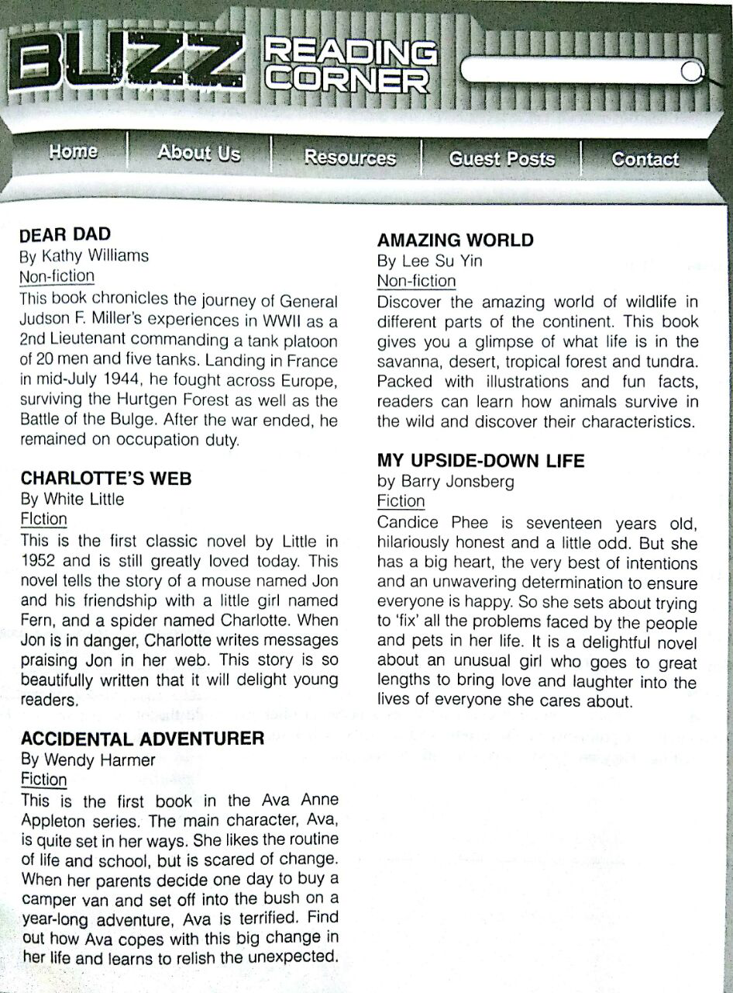
Questions 16 to 20

Using the information in the book reviews, answer each of the questions below. Write the title of the book.

Which review mentions… | Title of book
16. a character who helps a good friend?
17. a girl who is terrified of change?
18. the use of pictures to present information?
19. someone who helps people and animals?
20. a battlefield? | [5 marks]

Questions 21 to 25

Your friend has asked you to recommend a book. Using words from the book reviews, complete the email below. Use not more than three words.

Subject: | Good reads!
From: | koko@speedymail.com
To: | liming@vistana.com.my
Date: | Monday 19 December 2016, 7.15 pm
Hi Li Ming,

How are you? Two weeks ago, I came across a few book reviews on a webpage called (21)__________________________________. I personally would enjoy reading books about war (22) like ___________________________________. However, I know that you would prefer to read (23)_______________________________________ books, especially is there are strong female characters. I’d highly recommend (24) __________________________________
___________________ or (25) ___________________________________________________
________________________________________________. In one of the books, the main character faces a personal dilemma while the other one sets out to straighten out problems of the people and animals in her life. I think you will find these books fascinating. They are good reads that will enthrall you.

Regards,
Koko
[5 marks]

SECTION C
[25 marks]
[Time suggested: 50 minutes]

Questions 26 to 31 are based on the following passage.
1  2  3  4  5  6  7  8  9  10 | Drawn by the promise of the area’s spectacular underground scenery, Akmal, Deva and Justin set out to explore Gua Temor Caves in Jasin, Malacca. Akmal and Deva were friends at SMK Datok Murad; their buddy Justin was on leave from a college. Akmal and Justin had navigated the cave system the previous holidays, but neither had done any other technically demanding routes like this one that would require climbing and rappelling, and Deva was a complete novice. But the young men were fit and equipped with climbing ropes, head torches, and snacks.  The trio left their motorcycles at the Gua Tremor main entrance, hiked up the hill, and reached the mouth of the cave at 8 a.m. Judging by Akmal and Deva’s earlier expedition, they expected to reach the end of the cave to exit about six hours later. The descent began with an exhilarating slide down a slippery slope, then a 23 metre rappel down a waterfall.  Soon afterwards, the boys came to passages so low that they were forced to belly crawl. Justin had brought directions he had found online, but they were hazy; several times, the three friends hit what seemed like dead ends and were forced reverse course. At 2 p.m., they came to a rushing river where there should have been a narrow creek. Akmal and Deva went off to investigate, while an exhausted Justin lay down on the rocks and took a nap.  When the scouts returned, they reported that the river would indeed lead them out of the cave system. Afraid that the fast-moving water might sweep him downriver, Justin fastened a rope to a small stone arch to stabilise himself. But as he set foot into the water, the arch gave way, and he tumbled into the cold river. “I’m okay, guys,” Justin said, getting to his feet. But his clothes were soaked, and as he refastened the rope to a more secure pillar, he was shaking with cold. The trio then rappelled down a 6-metre deep pit without incident, but as Justin clambered down the other side, he fell again. Once more he insisted he was fine.  A while later, the boys reached a cave about 3 metres in diameter; the exit was blocked by a small mound. This mound, Justin said, could be caused by a landslide as there had been no block during his earlier visit to the cave with Akmal. Still, he thought it could be cut through easily with his axe.  Justin took turns with the others whacking at the mound. But the slope of the roof made it impossible to get a good swing. For hours, the boys rotated between chopping, resting under a space blanket, and pacing to keep off the chill. Sleep was out of the question-after dozing for a few minutes, they would jolt awake with chattering teeth.  To keep up their spirits, the boys prayed and told jokes. By late evening, however, they has a new reason to worry; as the hole in the mound slowly deepened, it was filled with mud water, which splashed them with each axe blow and further reduced the blade’s impact. None of them said what they were all thinking; at this rate, we’ll never break through.  Around 5.30 p.m., Akmal saw light penetrating from the other side of the mound. Hearing faint voices, the boys began shouting for help. Someone yelled back, “we’re coming!”  It took another 45 minute for members of the Tenom Search and Rescue team to clear away the thick mound. Finally a man in a hard hat climbed through the narrow opening. The search begun that evening, the rescuers explained, when Akmal and Deva’s classmate, Chin Woo, called to report them missing. Team membes guided the three relived boys through the last stretch of the cave, and the trio stepped into daylight for the first time in 7 hours. When the young men reached the entrance, at 7.30 p.m., friends and family members rushed to embrace them.  All told, the guys were not seriously injured, and the incident has not diminished their love of caving. They even plan to return to the caves the next holidays. | 5  10  15  20  25  30  35  40  45  50
26. From paragraph 1,
(a) Why did the three boys choose to go caving at Gua Temor Cave?

______________________________________________________________________________________________________________________________________________
[1 mark]

(b) Which phrase shows us that one of the boys had never gone caving before this?
______________________________________________________________________________________________________________________________________________
[1 mark]

27. From paragraph 3, give a piece of evidence that shows the boys had difficulties finding their way out of the cave.

______________________________________________________________________________________________________________________________________________
[1 mark]

28. (a) From paragraph 4, Justin kept saying he was fine after falling down on two occasions. What does this tell us about him?

______________________________________________________________________________________________________________________________________________
[1 mark]

(b) From paragraph 6, why did the boys have difficulty sleeping?

______________________________________________________________________________________________________________________________________________
[1 mark]

29. (a) From paragraph 7,
(i) What was the next problem faced by the boys?

______________________________________________________________________________________________________________________________________________
[1 mark]

(ii) “At this rate, we’ll never break through.” (line 40)
Explain what does this sentence mean.

______________________________________________________________________________________________________________________________________________
[1 mark]

(b) From paragraph 9, how did the search team know they had a mission to save the boys?

______________________________________________________________________________________________________________________________________________
[1 mark]

30. From paragraph 10, the boys planned to return to the caves again after the incident. What does this tell us about their characteristics? Give a reason to support your answer.

Characteristic: ______________________________________________________________________________________________________________________________________________
[1 mark]
Reason: ______________________________________________________________________________________________________________________________________________
[1 mark]

31. The three boys had a frightening experience when they were trapped in the cave.
Write a summary on
- what the boys did and the problems they faced
- how the boys were saved

Credit will be given for use of own words, but care must be taken not to change the original meaning.
Your summary must:
- Be in continuous writing form (not note form)
- Use materials from line 31 to line 52
- Not be longer than 130 words, including the 10 words given below

Begin your summary as follows:

Since the exit to the cave was blocked, the boys…

Question 31

________________________________________________________________________________________________________________________________________________________________________________________________________________________________________________________________________________________________________________________________________________________________________________________________________________________________________________________________________________________________________________________________________________________________________________________________________________________________________________________________________________________________________________________________________________________________________________________________________________________________________________________________________________________________________________________________________________________________________________________________________________________________________________________________________________________________________________________________________________________________________________________________________________________________________________________________________________________________________________________________________________________________________________________________________________________________________________________________________________________________________________________________________________________________________________________________________________________________________________________________________________________________________________________________________________________________________________________________________________________________________________________________________________________________________________________________________________________________________________________________________________________________________________________________________________________________________________________
SECTION D
[25 marks]
[Time suggested: 35 minutes]

Based on the poem below, answer the following questions.

THE LIVING PHOTOGRAPH
My small grandmother is tall there,
straight-back, white broderie anglaise shirt,
pleated skirt, flat shoes, grey bun,
a kind, old smile round her eyes.
Her big hand holds mine,
white hand in black hand.
Her sharp blue eyes look her own death in the eye.
It was true after all; that look.
My tall grandmother became small.
Her back round and hunched.
Her soup forgot to boil.
She went to the awful place grandmothers go.
Somewhere unknown, unthinkable.
But there she is still,
in the photo with me at three,
the crinkled smile is still living, breathing.
Jackie Kay

- How old was the persona when the photograph was taken?
__________________________________________________________________________________________________________________________________
[1 mark]

- In stanza 1, which phrase means “open embroidery on white linen”?
__________________________________________________________________________________________________________________________________
[1 mark]

- From stanza 2, give two evidence that shows the grandmother is affected by old age.
- ________________________________________________________________________________________________________________________
- ________________________________________________________________________________________________________________________
[2 marks]

- The poem shows how the persona loves and appreciate her grandmother.
Give an example of how you can show love and appreciation towards your family members.
__________________________________________________________________________________________________________________________________
_________________________________________________________________
[1 mark]

33 The following are the novels studied in the literature component in English Language :
Captain Nobody - Dean Pitchford
Sing to the Dawn - Minfong Ho
Dear Mr Kilmer - Anne Schraff

Choose any one of the novels above and answer the question below.
“Anything is possible when you have the right people there to support you”
Based on the above, discuss how a character overcomes challenges with the help of close family members/friends. Support your answer with close reference to the text.
[15 marks]
_______________________________________________________________________
____________________________________________________________________________________________________________________________________________________________________________________________________________________________________________________________________________________________________________________________________________________________________________________________________________________________________________________________________________________________________________________________________________________________________________________________________________________________________________________________________________________________________________________________________________________________________________________________________________________________________________________________________________________________________________________________________________________________________________________________________________________________________________________________________________________________________________________________________________________________________________________________________________________________________________________________________________________________________________________________________________________________________________________________________________________________________________________________________________
KERTAS SOALAN TAMAT

