Question 1
Soalan 1

Variation is differences between organism of the same species. Variation in plant can be shown by the different size/mass of fruits, length of leaves or colour of flower. These variation can be affected by light intensity, amount of water, amout of minerals or pH of soil.
Variasi adalah perbezaan di antara organisma daripada spesies yang sama. Variasi dalam tumbuhan boleh ditunjukkan oleh perbezaan saiz/jisim buah, panjang daun atau warna bunga. Variasi ini boleh dipengaruhi oleh keamatan cahaya, jumlah air, jumlah mineral atau pH tanah.

One experiment was carried out to investigate the effect of light intensity onto growth of tomato plants which contain the same genetic. The tomato plants were planted in two glass house with same other basic needs.
Satu eksperimen telah dijalankan untuk mengkaji kesan keamatan cahaya ke atas pertumbuhan pokok-pokok tomato yang mempunyai genetik yang sama. Pokok tomato tersebut telah ditanamkan di dalam dua rumah kaca dengan keperluan asas lain yang sama.

The following steps were carried out.
Langkah-langkah berikut telah dijalankan :

- 10 tomato plants were planted in glass house A.
10 pokok tomato telah ditanamkan di dalam rumah kaca A.

- While the other 10 tomato plants were planted in glass house B.
Manakala 10 pokok lagi telah ditanamkan di dalam rumah kaca B.

- Basic needs such as water and minerals were fixed for both glass house A and B.
Keperluan asas seperti air serta garam mineral telah ditetapkan bagi kedua-dua rumah kaca A dan B.

- For the factor of light intensity, tomato plants in glass house A were exposed to light about 12 hours daily while in glass house B, tomato plants were exposed to the light about 6 hours.
Bagi faktor keamatan cahaya, pokok-pokok tomato rumah kaca A telah didedahkan
kepada cahaya selama 12 jam sehari manakala pokok-pokok tomato rumah kaca B
telah didedahkan selama 6 jam.

- After 4 months, the tomato fruits which were planted in both glass houses shown differences in size and mass.
Selepas 4 bulan, buah tomato yang ditanamkan didalam kedua-dua rumah kaca didapati menunjukkan saiz serta jisim yang berbeza.

- Table 1 shows the result obtained from the experiment.
Jadual 1 menunjukkan keputusan yang diperolehi dari eksperimen :

Glass house  Rumah Kaca | Duration of tomato plant exposed to the light intensity daily (hour)  Tempoh masa keamatan cahaya didedahkan kepada pokok tomato setiap hari (jam) | Mass of 10 tomatoes  Jisim 10 biji tomato (kg) | Average mass of each tomato Purata Jisim bagi sebiji tomato (kg)
A | 12 | 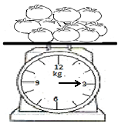
B | 6 | 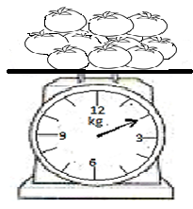
Table 1/ Jadual 1

(a) Record the mass of 10 tomatoes and calculate the average reading in Table 1.
Rekodkan jisim 10 biji tomato dan hitungkan purata bacaan dalam Jadual 1.
[ 3 marks/markah]
(b) (i) State two different observations made from Table 1.
Nyatakan dua pemerhatian berlainan dibuat daripada Jadual 1

Observation 1:
Pemerhatian 1:

..........................................................................................................................................

..........................................................................................................................................

...........................................................................................................................................

Observation 2:
Pemerhatian 2:

..........................................................................................................................................

..........................................................................................................................................
1(b)(i)

..........................................................................................................................................
[ 3 marks/markah]
(ii) State inferences from the observations in 1(b)(i).
Nyatakan inferens daripada pemerhatian di 1(b)(i)

Inference from observation 1:
Inferens daripada pemerhatian 1:

..............................................................................................................................................

..............................................................................................................................................

...............................................................................................................................................

Inference from observation 2:
Inferens daripada pemerhatian 2:

..............................................................................................................................................
1(b)(ii)

..............................................................................................................................................

............................................................................................................................................... [ 3 marks/markah]

(c) Complete Table 2 based on this experiment.
Lengkapkan Jadual 2 berdasarkan eksperimen ini.

Variable  Pembolehubah | Method to handle the variable  Cara mengendali pembolehubah
Manipulated variable:  Pembolehubah dimanipulasikan:  ....................................................................  ....................................................................  …………………………………………… | .........................................................................  .........................................................................  .........................................................................
Responding variable:  Pembolehubah bergerak balas:  ....................................................................  ....................................................................  .................................................................... | .........................................................................  .........................................................................  .........................................................................  .........................................................................
Constant variable:  Pembolehubah dimalarkan:  ....................................................................  ....................................................................  …………………………………………… | .......................................................................  .......................................................................  1(c)  ........................................................................  ……………………………………………….
Table 2
Jadual 2
[ 3 marks/markah]

(d) State the hypothesis for this experiment.
Nyatakan hipotesis bagi eksperimen ini.

..........................................................................................................................................
1(d)

..........................................................................................................................................

..........................................................................................................................................
[ 3 marks/markah]

(e)(i) Construct a table and record all the data collected in this experiment.
Your table should have the following titles:
Bina satu jadual dan rekodkan semua data yang dikumpul dalam eksperimen ini.
Jadual anda hendaklah mengandungi tajuk-tajuk berikut:

- Glass house
Rumah kaca

- Duration of tomato plant exposed to the light intensity daily.
Tempoh masa keamatan cahaya didedahkan kepada pokok tomato setiap hari

- Mass of 10 tomatoes
Jisim 10 biji tomato

- Growth rate of tomato
Kadar pertumbuhan tomato

.
Use the formulae:
Growth rate of tomato = Mass of 10 tomatoes
Time taken for planting
Gunakan formula:
Kadar pertumbuhan tomato = Jisim 10 biji tomato
Masa diambil untuk menanam

1(e)(i)

[ 3 marks/markah]

(e)(ii) Use the graph paper provided on page 8 to answer this question.
By using the data in 1(e)(i), draw a bar chart on the growth rate of tomato against
duration of tomato plant exposed to the light intensity daily.
Guna kertas graf yang disediakan di halaman 8 untuk menjawab soalan ini.
Menggunakan data di 1(e)(i) , lukis carta bar kadar pertumbuhan tomato melawan
1(e)(ii)

tempoh masa keamatan cahaya didedahkan kepada pokok tomato setiap hari

[3 marks/markah]

(e)(iii) Based on the bar chart in 1(e)(ii), explain the relationship between the growth rate of
tomato against duration of tomato plant exposed to the light intensity daily.
Berdasarkan carta bar dalam 1(e)(ii), terangkan hubungan di antara kadar
pertumbuhan tomato melawan tempoh masa keamatan cahaya didedahkan kepada
pokok tomato setiap hari

..........................................................................................................................................

..........................................................................................................................................
1(e)(iii)

..........................................................................................................................................

..........................................................................................................................................
[3 marks/markah]

(f) This experiment is repeated by exposing the tomato plant to the light intensity for 4
hours daily.
Predict the mass of 10 tomatoes that will be provided.
Explain your prediction.
Eksperimen ini diulangi dengan mendedahkan pokok tomato kepada keamatan cahaya
selama 4 jam sehari.
Ramalkan jisim 10 tomato yang akan diperolehi.
Terangkan ramalan anda.

..........................................................................................................................................

..........................................................................................................................................
1(f)

..........................................................................................................................................

..........................................................................................................................................
[3 marks/markah]

(g) Based on the result of this experiment, state the operational definition for
continuos variation
Berdasarkan keputusan eksperimen ini, nyatakan definisi secara operasi untuk
variasi selanjar

..........................................................................................................................................

..........................................................................................................................................
1(g)

..........................................................................................................................................

..........................................................................................................................................
[ 3 marks/markah]

(h) The following list is part of the apparatus and material used in this experiment.
Senarai berikut adalah sebahagian daripada radas dan bahan yang digunakan
dalam eksperimen ini

Light bulb Calendar Tomatoes Fertiliser Compression balance Tomato Plant
Mentol Kalendar Baja Tomato Neraca mampatan Pokok tomato

Complete Table 3 by matching each variable with the apparatus and material used in
this experiment
Lengkapkan Jadual 3 dengan memadankan setiap pembolehubah dengan radas dan
bahan yang digunakan dalam eksperimen ini.

Variable  Pembolehubah | Apparatus  Radas | Material  Bahan
Manipulated
Manipulasi
Responding
Bergerak balas
Controlled
Dimalarkan

1 (h)

Table 3/ Jadual 3

[3 marks/markah]

Question 2
Soalan 2

The level of water pollution can be tested by using the Biochemical Oxygen Demand (BOD) value At high BOD value the dissolved oxygen in the water is less, more anaerobic bacteria are present and the water is polluted.
Aras pencemaran air boleh diuji menggunakan nilai Keperluan Oksigen Biokimia (BOD). Pada nilai BOD yang tinggi oksigen terlarut dalam air adalah rendah, banyak bakteria anaerobik dan air adalah tercemar.

A group of student carried out an experiment to study the level of water pollution at a river stream . The river was used by the village for their daily activities. Water samples from station A, B and C are tested for this experiment.
Sekumpulan pelajar telah menjalankan satu eksperiment untuk mengkaji aras pencemaran air di suatu aliran sungai. Sungai tersebut telah digunakan oleh penduduk kampung untuk kegiatan harian mereka. Sampel-sampel air dari stesen A, B dan C telah diuji dalam eksperimen ini.

Design an experiment in the laboratory to study the level of water pollution at the different stations of river stream as shown in Diagram 2.
Rekabentuk satu eksperimen di dalam makmal untuk mengkaji aras pencemaran air di stesen –stesen yang berlainan pada aliran sungai seperti yang ditunjukkan dalam Rajah 2.

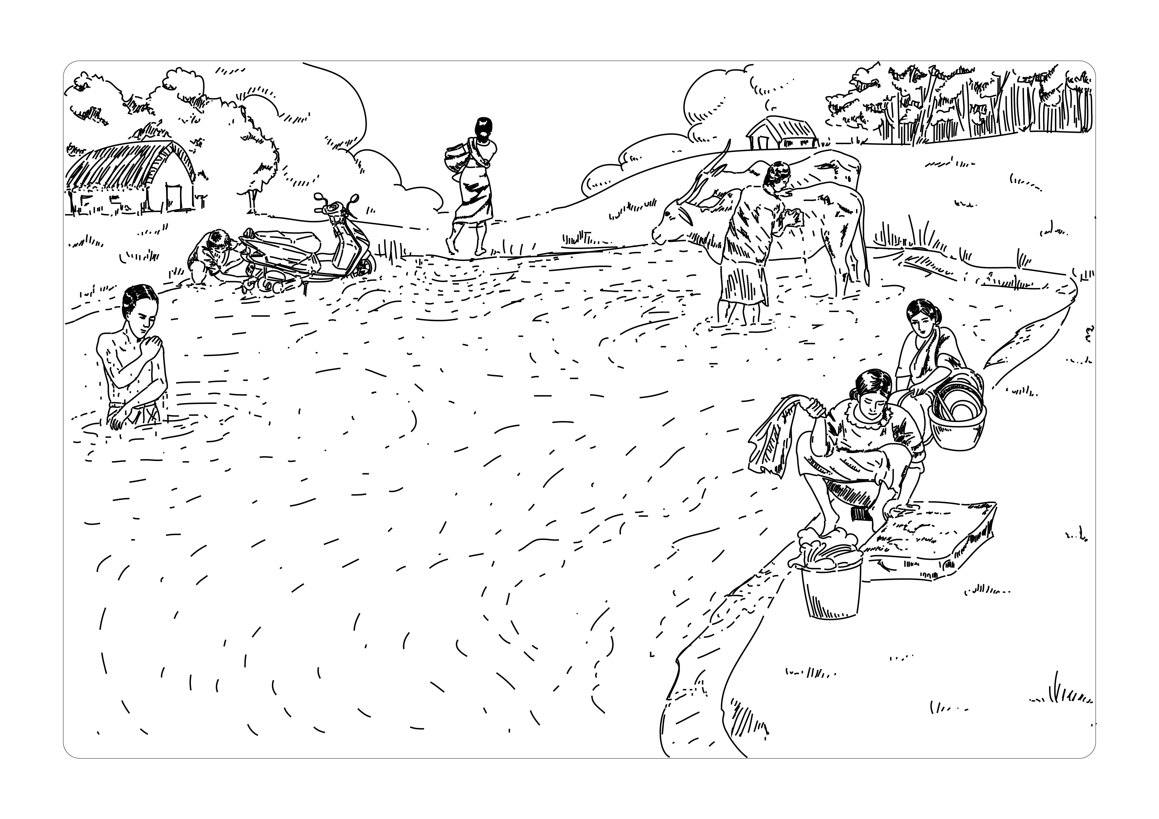
B
C
A
Diagram 2
Rajah 2

The planning of your experiment should include the following aspect:
Rancangan eksperimen anda hendaklah mengandungi aspek berikut:

- Problem statement
Pernyataan Masalah

- Hypothesis
Hipotesis

- Variables
Pembolehubah

- List of apparatus and materials
Senarai radas dan bahan

- Experimental procedure
Prosedur Eksperimen

- Presentation of Data Penyampaian Data
[ 17 marks]

END OF THE QUESTION PAPER

