### NAMA : ……………………………………………………………….............. TINGKATAN : …………..

### **SULIT**

4551/2

**Biologi**

KERTAS 2

Ogos/ Sept 2014

2 ½ jam

**PEPERIKSAAN PERCUBAAN SPM**

**SIJIL PELAJARAN MALAYSIA**

# BIOLOGI

Kertas 2

Dua jam tiga puluh minit

## JANGAN BUKA KERTAS SOALAN INI SEHINGGA DIBERITAHU

|  |  |  |  |
| --- | --- | --- | --- |
| Kod Pemeriksa | |  | |
| Bahagian | Soalan | Markah Penuh | Markah |
| A | 1 | 12 |  |
| 2 | 12 |  |
| 3 | 12 |  |
| 4 | 12 |  |
| 5 | 12 |  |
| B | 6 | 20 |  |
| 7 | 20 |  |
| 8 | 20 |  |
| 9 | 20 |  |
| **Jumlah** | | |  |

1. *Kertas soalan ini mengandungi dua bahagian :*

**Bahagian A** *dan***Bahagian B***.*

*2. Jawab* **semua** *soalan dalam* **Bahagian A.** *Jawapan kepada* **Bahagian A** *hendaklah ditulis dalam ruang jawapanyang disediakan*

*3. Jawab* **dua** *soalan dari* **Bahagian B** *dan jawapan kepada* **Bahagian B** *hendaklah ditulis dalam ruang bergaris yang disediakan dibahagian akhir kertas soalan. Anda diminta menjawab dengan lebih terperinci untuk* **Bahagian B***, Jawapan mestilah jelas dan logik. Dalam jawapan anda,persamaan,gambar rajah, jadual , graf dan cara lain yang sesuai untuk menjelaskan jawapan anda boleh digunakan.*

*4. Rajah yang mengiringi soalan tidak dilukis mengikut skala kecuali dinyatakan.*

*5. Markah yang diperuntukkan bagi setiap soalan atau ceraian soalan ditunjukkan dalam kurungan.*

1. *Sekiranya anda hendak membatalkan sesuatu jawapan, buat garisan di atas jawapan itu.*
2. *Anda dibenarkan menggunakan kalkulator saintifik yang tidak boleh diprogram. Walau bagaimanapun, langkah mengira perlu ditunjukkan*

*8. Masa yang dicadangkan untuk menjawab* **Bahagian A** *ialah 90 minit,* **Bahagian B** *60 minit.*

*9. Semua kertas jawapan hendaklah diserahkan di akhir peperiksaan.*

**Kertas soalan ini mengandungi 22 halaman bercetak.**

|  |  |  |  |  |  |  |  |
| --- | --- | --- | --- | --- | --- | --- | --- |
| *For*  *Examiner’s Use*  1  1(a)(i)  1  1(a)(ii)  3  1(a)(iii) | | **SECTION A**  Answer **all** the questions  *Jawab* ***semua*** *soalan*   1. Diagram 1.1 shows the structure of a pancreas cell as seen under an electron microscope.   *Rajah 1.1 menunjukkan struktur satu sel pankreas yang dilihat di bawah mikroskop elektron.*    **R:……………….**  **S :……………..**  **Q: ………………..**    **P**        Diagram 1.1// *Rajah* *1.1*   1. (i) Name the type of the cell   *Namakan jenis sel tersebut.*    ...............……………………………………………………………………………………  [1 *mark*]  (ii) State one reason for your answer in a (i).  *Nyatakan satu alasan bagi jawapan anda di (a)(i)*    .………………………………………………………..……………………………………  [1 *mark*]    (iii) Label structures Q, R and S on the Diagram 1.1  *Labelkan struktur Q, R dan S pada Rajah 1.1*    [3 *marks*] | | | | | |
| (b)(i) State the function of organelle contain structure P.  *Nyatakan fungsi organel yang mengandungi struktur P.*    ………..……………………………………………………………………………………  [1 *mark*]  (ii) State the component of structure P  *Nyatakan komponen struktur P*    ..............................................................................................................................................  [1 *mark*]  (iii) Diagram 1.2 shows part of the component of structure P.  *Rajah 1.2 menunjukkan sebahagian komponen struktur P.*  **X**  **Z**  **Y**  Diagram 1*.*2 // *Rajah 1.2*    Name the parts labelled X, Y and Z.  *Namakan bahagian yang berlabel X, Y and Z.*    X : ……………………………………………………………………..  Y : ……………………………………………………………………  Z : ………..………………………………………………………….  [3 *marks*]  (c) Diagram 1.3 is a leaf cross section shows cell T which contains a large number of organelle R*.*  *Rajah 1.3 adalah keratan rentas daun menunjukkan sel T yang mengandungi organel R dalam jumlah yang banyak.*    Diagram 1.3 // *Rajah 1.3*  **T** | | | | | *For*  *Examiner’s Use*  3  1(b)(iii)  1  1(b)(ii)  1  1(b)(i) | | |
| *For*  *Examiner’s Use*  **12**  **Total**  1  1(c)(ii)  1  1(c)(i) | | 1. Name cell T   *Namakan sel T.*  ............…………………………………………………………………………………..  [1 *mark*]  (ii) State why cell T has a large number of R.  *Nyatakan mengapa sel T mengandungi banyak organel R.*  ...............…………………………………………………………………………………  ................………………………………………………………………………………...  [1 *marks*] | | | | | |
| 2. (a) Diagram 2.1 shows the shape of red blood cells after being immersed for 30 minutes in three solutions with different concentration.  *Rajah 2.1 menunjukkan bentuk sel darah merah selepas direndam selama 30 minit dalam tiga larutan yang berbeza kepekatannya.*  bloodcells  bloodcells  Red blood cells in Q solution  *Sel darah merah dalam larutan Q*  Red blood cells in P solution  *Sel darah merah dalam larutan P*  Red blood cells in R solution  *Sel darah merah dalam larutan R*  bloodcells    Diagram 2.1  *Rajah 2.1*    Based on the Diagram 2.1  *Berdasarkan Rajah 2.1*  (i) State the condition of the red blood cells after being immersed in  *Nyatakan keadaan sel darah merah selepas direndam di dalam*    Solution P//*Larutan P* :......................................................................................  Solution Q//*Larutan Q* : ....................................................................................  [2 *marks*] | | | | | *For*  *Examiner’s Use*  2  2(a)(i) | | |
| *For*  *Examiner’s Use*  1  2(a)(ii)  3  2(b)  3  2(a)(iii) | | (ii) Name the type of solution R in which the red blood cells are immersed. *Namakan jenis larutan R yang mana sel darah merah direndam.*  ............................................................................................................................  [1 *mark*]  (iii) Explain your answers given in a(ii)  *Terangkan jawapan yang anda berikan di a(ii)*    ............................................................................................................................  ............................................................................................................................  ............................................................................................................................  ............................................................................................................................  [3 *marks*]  (b)  Food such as mushrooms, fruits, vegetables and fish can be preserved longer by using natural preservatives such as salt, sugar and vinegar.  *Makanan seperti cendawan, buah-buahan, sayur-sayuran dan ikan boleh diawet untuk tahan lama menggunakan bahan-bahan pengawet semulajadi seperti garam,gula dan cuka .*  Based on the statement, explain why vinegar is suitable to be used as the natural preservative for the preservation of garlic.  *Berdasarkan pernyataan di atas , terangkan mengapa cuka adalah sesuai digunakan sebagai pengawet semulajadi untuk bawang putih.*  ...................................................................................................................................  ...................................................................................................................................  ...................................................................................................................................  ...................................................................................................................................  [3 *marks*] | | | | | |
| (c) Diagram 2.2 shows the condition of herbaceous plant due to water shortage in soil.  *Rajah 2.2 menunjukkan keadaan pokok herba disebabkan oleh kekurangan air dalam tanah.*  C:\Users\Meli\Documents\DIAGRAN SPM0809\NO8 091.jpg      Water shortage after one week  *Kekurangan air selepas satu minggu*      Diagram 2.2  *Rajah 2.2*    Explain the condition of the plant in Diagram 2.2 after one week .  *Terangkan keadaan pokok dalam Rajah 2.2 selepas satu minggu.*  ...................................................................................................................................  ...................................................................................................................................  ...................................................................................................................................  ……….........................................................................................................................  [3 *marks*] | | | | *For*  *Examiner’s Use*  3  2(c)  **12**  **Total** | | |
| *For*  *Examiner’s Use*  1  3(a)  2  3(b)(i)  2  3(b)(ii) | | 3. Diagram 3.1 shows the example of the cell undergoing the division of cell.  *Rajah 3.1 di bawah menunjukkan contoh sel yang mengalami pembahagian sel*  D:\BIO RAJAH\TOPIKAL RAJAH BIO\RTOPIK 5\SEL INDUK.JPG  Diagram 3.1 // *Rajah 3.1*   1. How many chromosomes are there in the cell?   *Berapakah bilangan kromosom di dalam sel tersebut?*  …………………………………………………………………………………………..  [1 *mark*]   1. Draw one daughter cell at the end of the cell division through;   *Lukis satu sel anak yang dihasilkan melalui pembahagian sel secara;*   1. Mitosis   [2 *marks*]   1. Meiosis   [2 *marks*] | | | | |
| (c) Explain why the chromosomes numbers are different in daughter cells of mitosis and meiosis.  *Terangkan mengapa bilangan kromosom berbeza pada sel anak antara mitosis dan meiosis.*  ………………………………………………………………………………………….  ………………………………………………………………………………………….  ………………………………………………………………………………………….  [2 *marks*]   1. Explain one difference of importance of mitosis and meiosis to organisms.   *Terangkan satu perbezaan kepentingan mitosis dan meiosis kepada organisma hidup.*  ………………………………………………………………………………………….  ………………………………………………………………………………………….  ………………………………………………………………………………………….  [2 *marks*]   1. In a population of buffaloes, there are normal buffaloes and white buffaloes or known as ‘kerbau balar’. Why it is happen?   *Dalam satu populasi kerbau, terdapat kerbau yang normal dan kerbau yang berwarna putih atau dikenali sebagai ‘kerbau balar’. Mengapakah keadaan ini terjadi?*  ………………………………………………………………………………………….  ………………………………………………………………………………………….  ………………………………………………………………………………………….  ………………………………………………………………………………………….  [3 *marks*] | | | *For*  *Examiner’s Use*  2  3(c)  2  3(d)  3  3(e)  **12**  **Total** | | |
| *For*  *Examiner’s Use*  2  4(a)  3  4(b)  2  4(c) | | 4. Diagram 4 shown a part of the human body limb that involved in movement.  *Rajah 4 menunjukkan sebahagian daripada anggota badan manusia yang terlibat dalam pergerakan.*  Skapula  Humerus  **X**  **Y**  **R**  **S**  Radius  Ulna  lengan  Diagram 4 // *Rajah 4*  a) Name the structure tissue R and the type of joint S  *Namakan struktur tisu R dan jenis sendi S*  (i) R tissue / *Tisu R*: ………………………………………………………………    (ii) Type of joint S / *Jenis sendi S*: ………………………………….……………..  [2 *marks*]  b) Explain the function of X muscle, Y muscle and structure R in produced the limb position shows in Diagram 4.  *Terangkan peranan otot X, otot Y dan R dalam menghasilkan keadaan anggota seperti dalam Rajah 4.*  .................................................................................................................................  .................................................................................................................................  .................................................................................................................................  .................................................................................................................................  [3 *marks*]  c) Explain why muscle X and Y must work in pair to produce the movement.  *Terangkan mengapa otot X dan Y mesti bekerja dalam pasangan bagi menghasilkan pergerakan.*  ....................................................................................................................................  ....................................................................................................................................  ....................................................................................................................................  [2 *marks*] | | |
| d) Based on Diagram 4, explain **two** importance of skeletal part in movement.  *Berdasarkan Rajah 4, terangkan* ***dua*** *kepentingan bahagian rangka tersebut dalam pergerakan.*  ...............................................................................................................................................  ...............................................................................................................................................  ...............................................................................................................................................  ...............................................................................................................................................  [2 *marks*]  e) Explain what happened to the movement of arm if the tissue R is torn.  *Terangkan apakah yang berlaku kepada pergerakan tangan jika tisu R terkoyak.*  ...............................................................................................................................................  ...............................................................................................................................................  ...............................................................................................................................................  ...............................................................................................................................................  [3 *marks*] | | | *For*  *Examiner’s Use*  3  4(e)  2  4(d)  **12**  **Total** | | |
| *For*  *Examiner’s Use*  1  5(a)(i)  3  5(a)(ii) | | 5. Diagram 5.1 show the operational machine to treat an individual with the failure  function of the kidney.  *Rajah 5.1 menunjukkan pengoperasian sejenis mesin untuk merawat individu yang*  *mengalami kegagalan organ ginjal berfungsi.*  Blood flow from arm artery // *Aliran darah dari arteri lengan*    Semipermeable tube //  *Tiub separa telap*  Dialysis fluid // *Bendalir dialisis*  Excess salt and urea //  *Urea dan garam berlebihan*  Blood flow to arm vein *//* *Aliran darah ke vena lengan*  Diagram 5.1 // *Rajah 5.1*  Based on Diagram 5.1;  *Berdasarkan Rajah 5.1;*   1. (i) Name the machine   *Namakan mesin itu.*  ………………………………………………………………………………  [1 *mark*]  (ii) Explain how the function of the machine.  *Terangkan bagaimana mesin tersebut berfungsi.*  ………………………………………………………………………………  ………………………………………………………………………………  ……………………………………………………………………………….  ……………………………………………………………………………….  [3 *marks*] | | |

|  |  |  |
| --- | --- | --- |
| 1. A teenager who sympathy with the patient in Diagram 5.1 donate one of his kidney. When the patient recovered, he was served with salted “sup tulang”   *Seorang remaja yang simpati dengan pesakit dalam Rajah 5.1 telah mendermakan salah satu organ ginjalnya. Apabila pesakit itu sihat, dia telah dihidangkan dengan sup tulang yang masin*   1. State the effect to volume and concentration of his urine   *Nyatakan kesan terhadap isipadu dan kepekatan air kencing yang dihasilkannya.*  …………………………………………………………………………………  [1 *mark*]   1. Explain your answer in (b)(i)   *Terangkan jawapan anda di (b)(i).*  …………………………………………………………………………………  …………………………………………………………………………………  …………………………………………………………………………………  …………………………………………………………………………………  [3 *marks*]   1. Diagram 5.2 show the structure of nephrone in kidney   *Rajah 5.2 menunjukkan struktur nefron yang terdapat di dalam ginjal.*  Diagram 5.2 // *Rajah 5.2* | | *For*  *Examiner’s Use*  3  5(b)(ii)  1  5(b)(i) |
| *For*  *Examiner’s Use*  2  1(c)(ii)  2  1(c)(i)  **12**  **Total** | | 1. On Diagram 5.2, label the structure of distal convoluted tubul as X, collecting duct, Y and proximal convoluted tubule, Z   *Pada Rajah5.2, labelkan strukur tubul berlingkar distal sebagai X, tubul pengumpul , Y dan tubul berlingkar proksimal, Z.*  [2 *marks*]  (ii) Tabel 1 shows the product urine analysis which cross the nephrone of kidney.  *Jadual 1 menunjukkan hasil analisis kandungan bahan dalam air kencing seseorang yang telah melalui nefron ginjal*   |  |  |  |  |  | | --- | --- | --- | --- | --- | | **Percentage of urine composition**  ***Peratus kandungan bahan dalam air kencing (%)*** | | | | | | Glucose  *Glukosa* | Amino Acids  *Asid amino* | Water  *Air* | Mineral salts  *Garam mineral* | Urea  *Urea* | | 0.0 | 0.0 | 95.0 | 2.65 | 2.0 |   Based on the table above, explain why no glucose and amino acid present in urine  *Berdasarkan jadual di atas, terangkan mengapa tiada molekul glukosa dan asid amino di dalam air kencing itu.*  ………………………………………………………………………………………….  ………………………………………………………………………………………….  ………………………………………………………………………………………….  [2 *marks*] | | |

**SECTION B**

[40 *marks*]

Answer **any** two questions from this section

*Jawab mana-mana* ***dua*** *soalan daripada bahagian ini*

6. Diagram 6.1 shows the digestive system and organs associated with digestion.

*Rajah 6.1 menunjukkan sistem pencernaan dan organ-organ berkaitan pencernaan*.

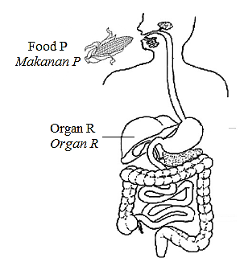

Diagram 6.1

*Rajah 6.1*

1. Based on Diagram 6.1,

*Berdasarkan Rajah 6.1,*

(i) Name the organs that are involved in the processing of food P

*Namakan organ-organ yang terlibat dalam memproses makanan P*

[3 *marks*]

(ii) Explain the processes which occur to the food P until it can be used by body

cells.

*Terangkan proses-proses yang berlaku kepada makanan P sehingga boleh*

*digunakan oleh sel-sel badan.*

[7 *marks*]

Organ R acts as a checkpoint which controls the amount of nutrients released into the blood circulatory system *Organ R merupakan pusat kawalan yang mengawal kuantiti nutrien yang masuk ke dalam sistem peredaran darah*

Based on the above statement, explain the role of organ R in assimilation of nutrients in foods P.

*Berdasarkan pernyataan di atas, terangkan peranan organ R dalam asimilasi nutrien dalam makanan P.*

[5 *marks*]

1. Diagram 6.2 shows a gastric bypass surgery is used to treat severe obesity.

*Rajah 6.2 menunjukkan satu pembedahan pintasan gastrik yang digunakan untuk merawat kes obesiti yang teruk.*

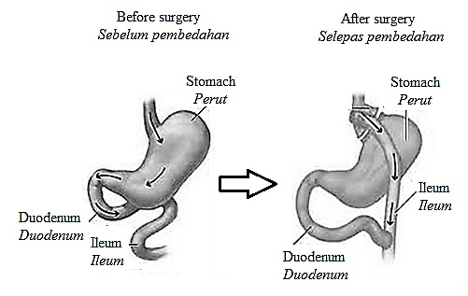

**Effect after surgery**

***Kesan selepas pembedahan***

Stomach become too small

*Perut menjadi sangat kecil*

Smaller stomach connected

to the middle parts of the

small intestine

*Perut yang kecil dihubungkan*

*ke bahagian tengah*

*usus kecil*

Diagram 6.2

*Rajah 6.2*

Explain how the above operation can reduce excessive weight problems.

*Terangkan bagaimana pembedahan di atas dapat mengurangkan masalah berat badan yang berlebihan.*

[5 *marks*]

7(a) Diagram 7.1 shows the development of pollen.

*Rajah7.1 menunjukkan perkembangan debunga.*

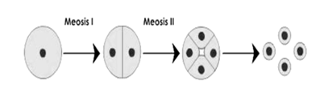

Pollen mother cell Tetrad Pollen

*Sel induk debunga Tetrad Debunga*

Diagram 7.1 // *Rajah 7.1*

Describe the development of pollen based on the diagram above.

*Huraikan perkembangan debunga berdasarkan rajah di atas.*

[ 4 *marks*]

(b) Diagram 7.2 shows the mature carpel where the process of double fertilisation occurs in the plant. Explain the process.

*Rajah 7.2 menunjukkan karpel matang dimana proses persenyawaan gandadua dalam tumbuhan berlaku.Terangkan proses tersebut.*

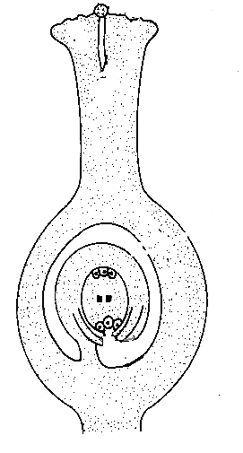

Diagram 7.2 // *Rajah 7.2*

[6 *marks*]

(c) Diagram 7.3 shows the process of secondary growth in plant.

*Rajah 7.3 menunjukkan proses pertumbuhan sekunder dalam tumbuhan.*

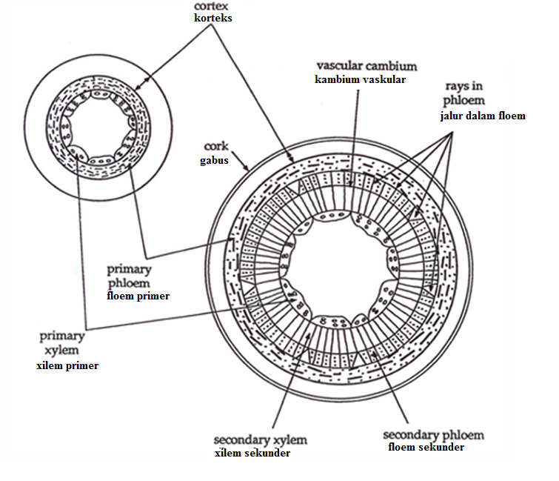

Diagram 7.3 // *Rajah 7.3*

Based on the above diagram, explain the process of secondary growth in plant

*Berdasarkan rajah di atas, terangkan proses pertumbuhan sekunder dalam tumbuhan.*

[6 *marks*]

(d) Explain the important of secondary growth in plant.

*Terangkan kepentingan pertumbuhan sekunder dalam tumbuhan.*

[4 *marks*]

8. (a) Microorganisms S and T as shown in Diagram 8.1 are very useful and widely used in the field of biotechnology.

*Mikroorganisma S dan T yang ditunjukkan dalam Rajah 8.1 sangat berguna dan digunakan secara meluas dalam bidang bioteknologi.*

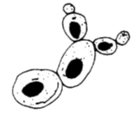 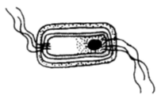

Microorganism S Microorganism T

*Mikroorganisma S Mikroorganisma T*

Diagram 8.1 // *Rajah 8.1*

Explain with suitable examples how both microorganisms are commercially used.

*Dengan menggunakan contoh-contoh yang sesuai, terangkan bagaimana mikroorganisma tersebut digunakan secara komersial*.

[4 *marks*]

(b) Diagram 8.2 shows a waste material from households is piped into a large settling tank in sewage treatment plant.

*Rajah 8.2 menunjukkan bahan buangan dari perumahan disalurkan ke dalam tangki pemendapan di loji rawatan kumbahan*.

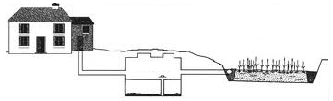

Wetland

Septic Tank

Diagram 8.2 // *Rajah 8.2*

Biotechnology are used in the waste treatment process at septic tank. Explain.

*Penggunaan bioteknologi berlaku dalam proses rawatan kumbahan di tangki septik. Terangkan.*

[6 *marks*]

(c) Diagram 8.3 (i) shows a type of microorganism. Microorganism Q has both the characteristics of living things and non-living things. All microorganisms from this group are parasites and causes disease on human, animals and plants.

*Rajah 8.3 (i) menunjukkan sejenis mikroorganisma. Mikroorganisma Q mempunyai kedua-dua ciri benda hidup dan ciri benda bukan hidup. Kesemua mikroorganisma dari kumpulan ini adalah parasit dan menyebabkan pelbagai penyakit ke atas manusia, haiwan dan tumbuhan*.

Microorganism Q

*Mikroorganisma Q*

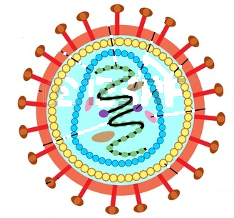

Diagram 8.3(i) // *Rajah 8.3(i)*

Microorganism Q

RNA microorganism Q

DNA microorganism Q

Combination

DNA T-lymphocyte and DNA microorganism Q

Progeny Microorganism Q

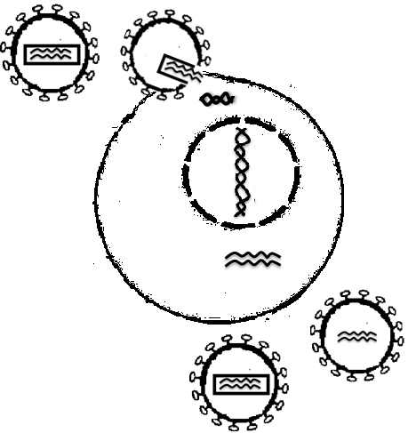

Diagram 8.3 (ii) // *Rajah 8.3(ii)*

Diagram 8.3(ii) shows the microorganism Q destroys the T-lymphocytes in the immune system on human. As a result, the number of lymphocytes is greatly reduced and cause a deadly disease because until now a vaccine to prevent this disease has not been found. These disease crippled the immunity system and the ability of the body to resist infections.

*Rajah 8.3 (ii) menunjukkan mikroorganisma Q memusnahkan sel limfosit T dalam sistem keimunan pada manusia. Kesannya, bilangan limfosit berkurang dan menyebabkan sejenis penyakit yang berbahaya kerana sehingga kini vaksin untuk mencegah penyakit ini masih belum ditemui. Penyakit ini melumpuhkan sistem imuniti dan keupayaan badan untuk menentang jangkitan.*

Explain the characteristics of microorganism Q and how it is transmitted among human. Suggest how to prevent that disease from spreading.

*Terangkan ciri-ciri mikroorganisma Q dan bagaimana ia berjangkit di kalangan manusia. Cadangkan bagaimana untuk mencegah penyakit tersebut daripada merebak*.

[10 *marks*]

9.(a)(i) Diagram 9.1 and 9.2 shows the histogram about distribution of genetic variation in human.

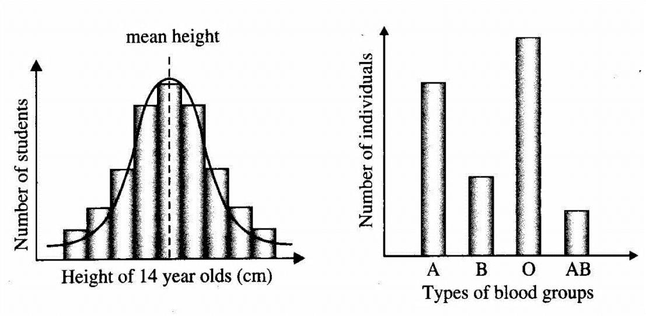 *Rajah 9.1 dan 9.2 menunjukkan histogram mengenai taburan variasi genetik dalam manusia.*

Diagram 9.1 Diagram 9.2

*Rajah 9.1 Rajah 9.2*

With a suitable example, explain the differences of two kinds of variation.

*Dengan menggunakan contoh yang sesuai, terangkan perbezaan di antara kedua-dua variasi tersebut.*

[7 *marks*]

(ii) What is the importance of variation to organism?

*Apakah kepentingan variasi kepada organisma?*

[3 *marks*]

(b) Diagram 9.3 and 9.4 shows the genetic factors that affected on the variation of organism.

*Rajah 9.3 dan 9.4 menunjukkan faktor-faktor genetik yang memberi kesan ke atas variasi pada organisma.*

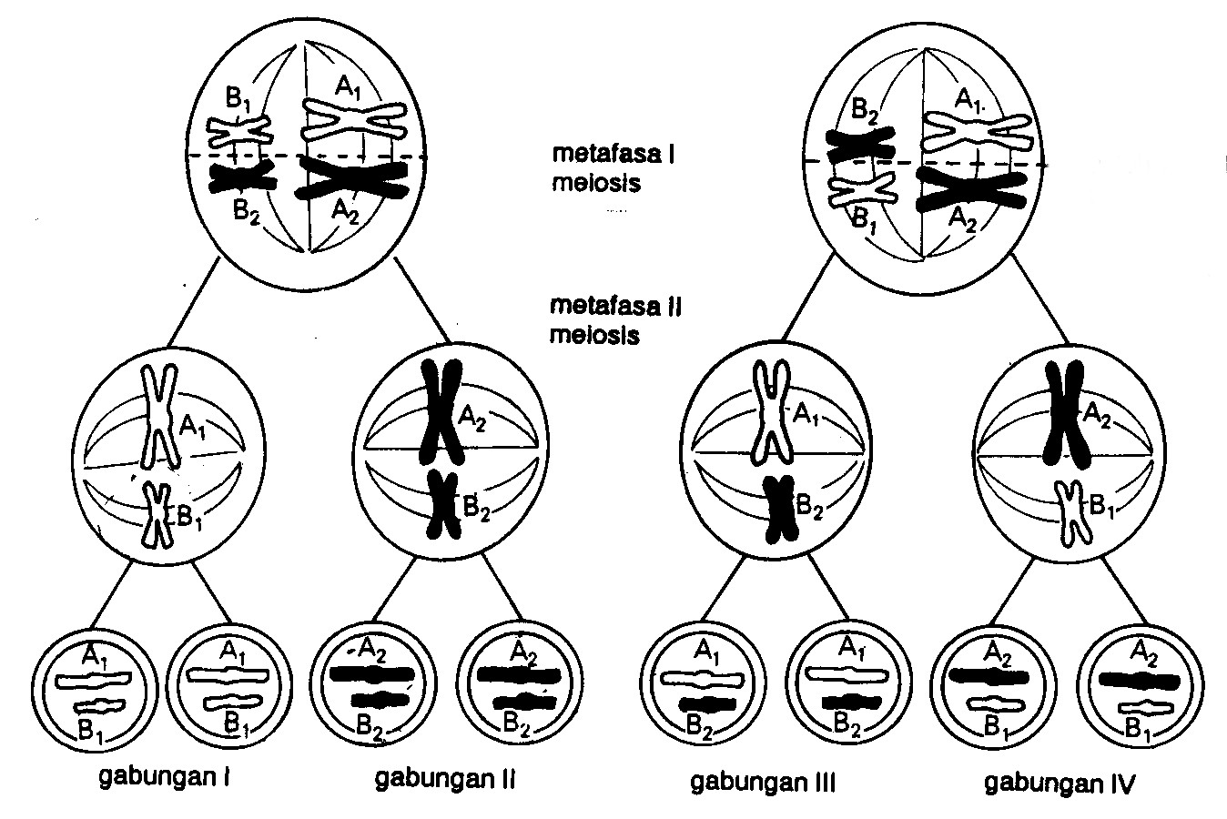

Combination 4

*Gabungan 4*

Combination 1

*Gabungan 1*

Combination 2

*Gabungan 2*

Combination 3

*Gabungan 3*

Diagram 9.3 // *Rajah 9.3*

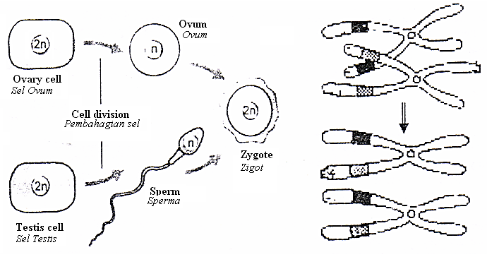

Diagram 9.4 // *Rajah 9.4*

Explain how these factors in the diagram above will cause the variation among the organism.

*Terangkan bagaimana faktor-faktor dalam rajah di atas akan menyebabkan variasi dikalangan organisma.*

[10 *marks*]

**END OF THE QUESTIONS**