Section A
[15 marks]
[Time suggested: 25 minutes]

Question 1 to 8 are based on the given stimuli. Study the information carefully and choose the best answer.

Volcano eruption in Iceland disrupts air travel in Europe

- From the headline above, we know that flights in Europe have been

- disturbed
- disordered
- suspended
- interrupted

CLERK
Requirement:
- SPM with 3 credits
- Good communication skills
- Fluency in English
- 2 years working experience in a reputable hotel

If you are interested, please send your resume to ramli@raya.com or contact Encik Ramli at 012-1234567

Raya Hotel

Section A
- Which of the following qualification is not essential for the position advertised?

- Proficient in English and Malay languages
- Working experience in the relevant area
- Possess good communication skills
- SPM qualifications
Lee lived alone. He looked older than fifty years; his skin was sun-baked and blemished, his forehead covered with deep lines. He has few teeth which were rarely seen as he had few reasons to smile. His only companion was his cat, smiley whom he loved. Smiley offered unquestioning love, loyalty and affection.

- Based on the extract above, we can conclude that Mr Lee
- has no family
- is a very old man
- is a very lonely man
- does not like to smile because he has no teeth

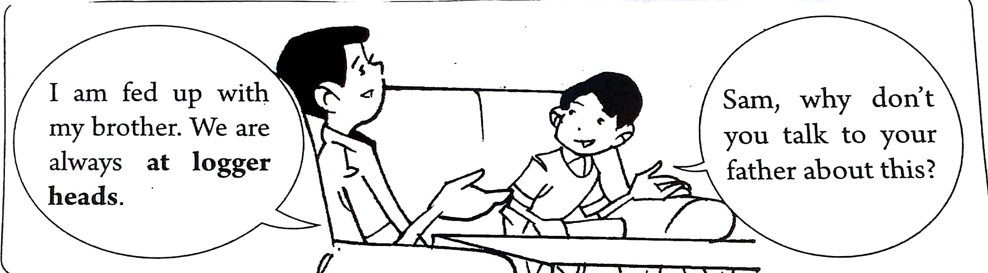

- From the dialogue above, the phrase at logger heads means that Sam and his brother are
- always banging their heads
- always exchanging ideas
- always arguing with each other
- always thinking of interesting things to do.

HOW WASTE PAPER IS RECYCLE
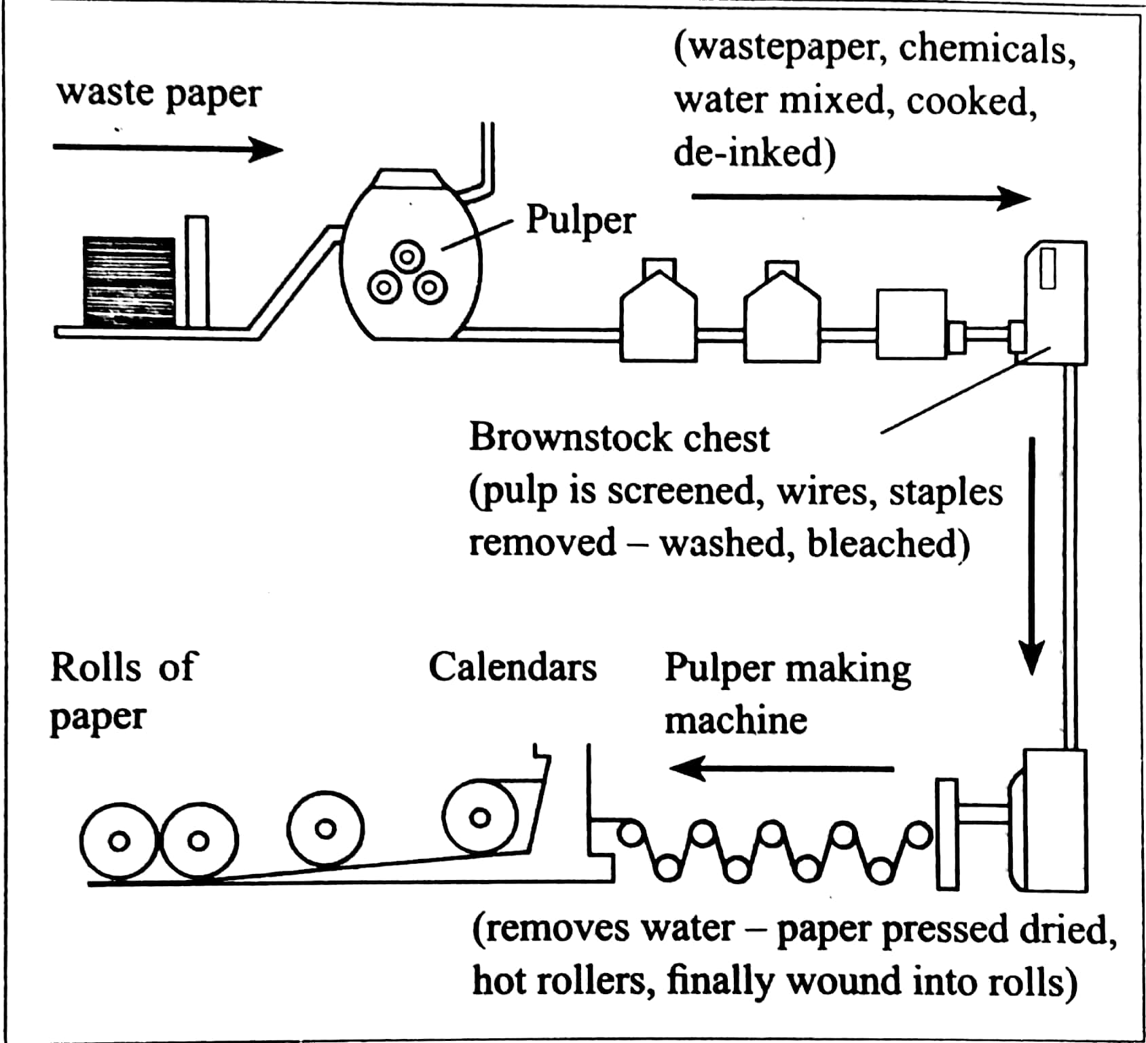

- From the flow chart above, which of the following statement is true?

- Wastepaper is mixed in the pulper with chemicals.
- Wastepaper is cooked in the pulper with oil.
- Pulp is screened in the Pulper Making Machine.
- The final products of recycling are rolls or cloth.

Dear Aunt Mary,
I really wish you were here with me. My housing area has been hit by floods. Flood waters have breached waist level. Our kitchen and ground floor bathroom have been affected. We have been told to prepare for evacuation and deployed volunteers would be assisting us. It is very tough as our ailing mum is not able to walk and we can’t use the wheelchair too!
Kerry Ann

- The writer wishes to express her
- plight
- condition
- circumstance
- responsibility

- From the letter, we know that the writer has to
- volunteer to help her neighbours.
- leave her mother who is bedridden.
- get ready to leave her house and belonging.
- clear all the water in the kitchen and bathroom.

This is life

Stop and smell the roses and embrace little joy

- The message in the sign suggests that
- life should be filled with simple pleasures.
- we must live only in a beautiful environment.
- we must put a stop to having a good things in life.
- life will be meaningful when we have the best things.

Question 9 to 15 are based on the following passage. Choose the best answer to fill in each blank.
This story is of a man who has four sons. He wanted to teach ____ (9) an important lesson. So he sent his sons, one after another, to look ____ (10) a pear tree a great distance away. The first son left in winter, the second son in spring, the third in summer and the youngest in autumn.
________(11) his sons had completed their tasks, they returned home. Soon, he gathered them together to relate what they had seen. The first son claimed that the pear tree ______(12) ugly and twisted. The second one told him it was covered with green buds. The third one describe it as ______ (13) a lot of sweet-smelling flowers and finally the youngest son reported that it was full of fruits.
The man explained the _____ (14) of the tasks. He advised his sons not to judge things too _____(15) , just as they should not judge a tree by only one season. He said that they should not pass judgement on a person by looking at only one incident.
(Adapted from The Star, Jan 2005)
- A them 14. A purpose
B they B result
C their C event
D theirs D plan

- A at 15 A hastily
B for B blindly
C into C strictly
D around D harshly

- A When
B Then
C While
D Afterwards

- A look
B looks
C looked
D looking

- A having
B have
C has
D had

Section B
[10 marks]
[Time suggested : 25 minutes]

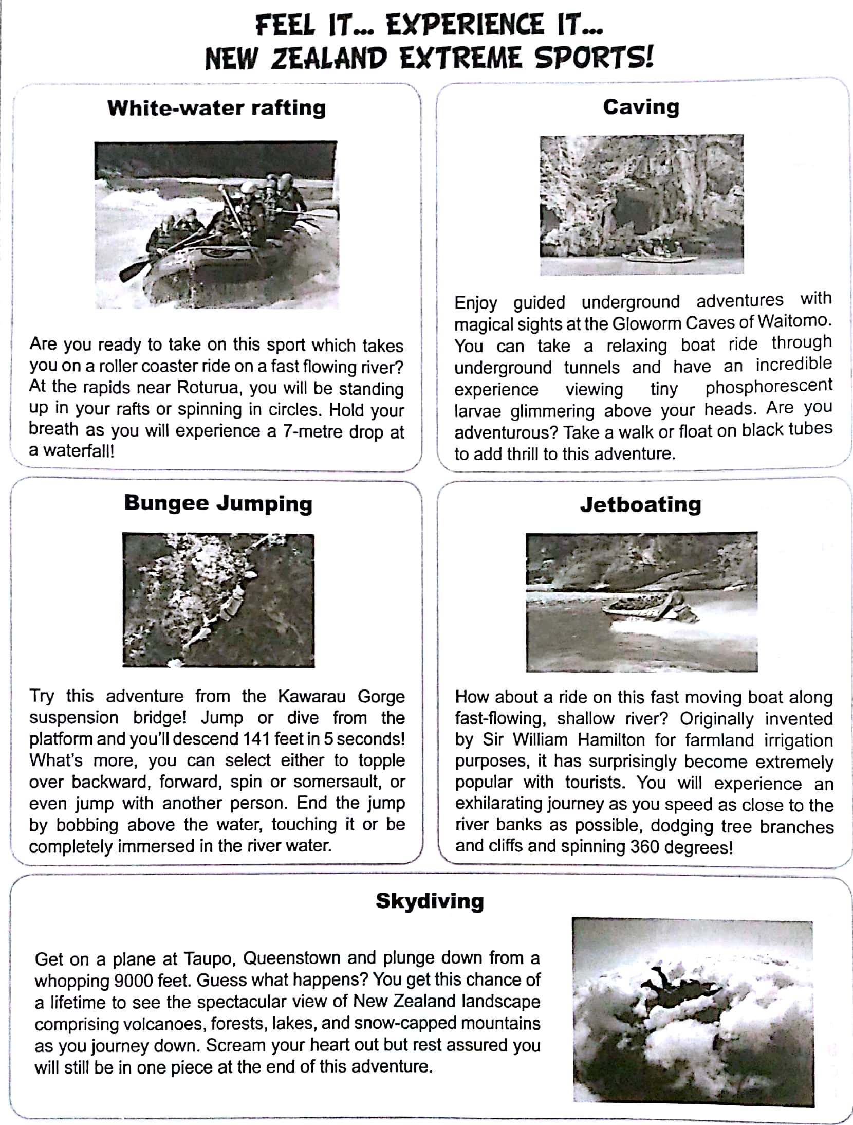
Section B
[10 marks]
[Time suggested : 25 minutes]

Complete the following email to a friend based on the advertisement. Use no more than three words.

To : | pinkaishah@gmail.com
From : | angelflowerr@gmail.com
Subject : | Holiday in New Zealand
Dear Aishah,

I am very excited over your suggestion to take a trip overseas and, most of all, to have an adventure holiday together with the four of us.

Guess what? I have found the perfect holiday for young thrill-seekers like us. Let us challenge ourselves and try our hand at (16) ___________________ in New Zealand.

First of all, we can take a leap of faith by (17) _____________________ from a suspension bridge. Then, we can enjoy the glittering view of (18) _________________ on the roof of the Gloworm Caves. To explore these caves you can walk or float on (19) ________________. However, for those who are less energetic, they can take a (20) ________________ .

Wouldn’t you like to engage in a water activity? Well, then I suggest jetboating! We will ride on a boat at great-speed down a (21) __________________. Alternatively, we could go white-water rafting where we will be challenged at (22) ____________________. Hold your breath because you will feel as if you are on a (23) ______________________.

Finally, we can head to (24) _____________________ where we will plunge down 9000 feet. It will be such a thrill to enjoy the panoramic view of (25) _______________________ at that great height.

Doesn’t all that sound exciting? What do you think? Please reply soon.

Your friend,

Rishi

Section C
[25 marks]
[Time suggested : 50 minutes]

Question 26 to 31 are based on the following passage.

1  2  3  4  5  6  7  8  9  10 | That morning on December 10, 2010, Roma Taljera arrived at the call centre bright and early. She had been working there for two years and loved her job, connecting with customers and making new friends. After work that Friday, she headed home alone after her shift, looking forwards to having supper with her parents and brother, and a long phone chat with her fiancé Vijay.  Managing to squeeze herself into a ladies’ compartment on the Mumbai suburban electric train, she tried to settle into a corner near the door. Jammed between other women, she was trying to find some space to stand safely on when she suddenly got pushed, lost her foothold and was thrown out of the coach.  Baleshwar Mishra has a very different story. The lanky youngster, an unemployed high school dropout, has recently come to Mumbai to look for a job. His job hunt had proved fruitless and he was running out of options. He had spent his day with a friend, watched a movie and boarded the train. Standing near the door of his train speeding in the opposite direction, he could not believe what he had just seen - a young woman in black salwar kameez lying next to the tracks.  “There’s a girl by the tracks!’ people cried out. Impulsively, Baleshwar grabbed the train’s red emergency chain and pulled it down frantically. The train screeched, slowing down. “Let’s go and help her!” he shouted to the other passengers. But nobody volunteered, afraid of getting involved, of being inconvenienced perhaps. His heart hammering in his chest, Baleshwar jumped off the still-moving train. As he landed on the ground, a burst of pain shot up his ankle. But there was no real damage. He got up and started to sprint back between the tracks as his train picked up the speed again and disappeared. “I hope I am not too late,” he thought, gasping for breath. After running for several times, he found her sprawled by the side of the tracks. “Sister, are you alright?’ But there was no response and no help in sight.  Baleshwar could see blood flowing out of the gash behind the young woman’s head. Saying a silent prayer, he lifted Roma gingerly and made his way away across the track, searching for a way out. He crossed through some shrubbery and followed the direction of the sounds until he found the road. “My sister is injured,” he implored motorists who drove by. “Please help me take her to the hospital.” But no one stopped.  Just when he was beginning to lose hope, a tempi-truck pulled over and its middle -aged driver steeped out. “Help me,” Baleshwar pleaded and the man helped him lay Roma down in the back of his truck. Ten minutes later, they arrived at a small hospital. But as the facility lacked personnel and equipment, the on-duty physician was not able to do more than give basic first aid. He advised that she be moved to a bigger hospital nearby. Baleshwar and the driver had no choice but to move her back into the truck. When the vehicle moved, Roma stirred and opened her eyes. Before she blacked out again, Baleshwar managed to her name and her brother Dinesh’s mobile phone number. he used the driver’s phone to call Dinesh  Dinesh rushed to the hospital and arrived at Divine Hospital minutes later. Dr Agarwal, the medical director there, admitted her immediately to the intensive care unit. He asked Baleshwar to hang around until Roma’s family arrived. They noticed then the driver, having done all he could, had left quietly, “Oh, I couldn’t thank him!” Baleshwar thought.  Roma was still unconscious. But her X-rays showed that although the injuries looked severe, all she needed were deep wound sutures. There would be no lasting damage, but Dr Agarwal believed she could have bled to death had nobody helped her. When Roma finally opened her eyes that night, her brother and fiancé were by her side. She could barely speak; she just nodded and fell asleep again.  When Baleshwar came to meet her the next morning, Roma was still partly sedated. Her fiancé, Vijay, struggled to find the words. “Thank you,” he finally said to a smiling Baleshwar. Roma was amazed to learn of the manner in which she had been rescued. “I think it’s astonishing that a stranger would jump off a train and risk his life for me. I can never repay Baleshwar.  “I am new to Mumbai, but I notice that people here are afraid,” Baleshwar, who is still looking for a job, say. “They fear getting trapped in the courts or with the police.” So why did he do it? “She needed help,” he simply says. “That day, it was Roma. Tomorrow, it could be you or me by the tracks, bleeding and alone.” | 5  10  15  20  25  30  35  40  45  50

- (a) From paragraph 1, which part of her job did Roma love?

…………………………………………………………………………………………

………………………………………………………………………………………… [1 mark]

(b) From paragraph 2, how did Roma fall from the coach on her way home on 10 December 2010?
…………………………………………………………………………………………
………………………………………………………………………………………… [1 mark]
- (a) From paragraph 3, what was Baleshwar doing in Mumbai?

………………………………………………………………………………………..

……………………………………………………………………………………….. [1 mark]

(b) From paragraph 4, why did Baleshwar pull the emergency chain in the train?

………………………………………………………………………………………..

……………………………………………………………………………………….. [1 mark]

- From paragraph 5 and 6, what two problems did Baleshwar encounter while trying to get medical treatment for Roma?

(i) ……………………………………………………………………………………

…………………………………………………………………………………… [1 mark]

(ii) ………………………………………………………………………………….

………………………………………………………………………………… .. [1 mark]

- (a) From paragraph 7, why do think the driver left without seeing Baleshwar?

………………………………………………………………………………………...

……………………………………………………………………………………….. [1 mark]

(b) From paragraph 10, what did Baleshwar notice about the people in Mumbai?

……………………………………………………………………………………….

……………………………………………………………………………………… [1 mark]

- In your own words, state one quality of Baleshwar that you admire.
Provide a reason to support your answer.

Quality : …………………………………………………………………………… [ 1 mark]

\Reason: …………………………………………………………………………….

…………………………………………………………………………….. [1 mark]

- Baleshwar Mishra endeavoured to save a young girl who had fallen off a moving train even though he did not know her.
Write a summary on what he faced in his attempt to get her to the hospital.
Credit will be given for use of own words but care must be taken not to change the original meaning.
Your summary must:
- be in continuous writing form (not note form)
- use material line 13 to the end
- not be longer than 130 words, including the 10 words given below.
Begin your summary as follows:
Baleshwar was standing near the door of his moving rain…
[15 marks]
………………………………………………………………………………………………………..
………………………………………………………………………………………………………..
………………………………………………………………………………………………………..
………………………………………………………………………………………………………..
……………………………………………………………………………………………………….
………………………………………………………………………………………………………..
………………………………………………………………………………………………………..
………………………………………………………………………………………………………..
………………………………………………………………………………………………………..
……………………………………………………………………………………………………….
………………………………………………………………………………………………………..
………………………………………………………………………………………………………..
………………………………………………………………………………………………………..
………………………………………………………………………………………………………..
……………………………………………………………………………………………………….
………………………………………………………………………………………………………..
………………………………………………………………………………………………………..
………………………………………………………………………………………………………..
………………………………………………………………………………………………………..
…………………………………………………………………………………………………………..
………………………………………………………………………………………………………..
………………………………………………………………………………………………………..
………………………………………………………………………………………………………..
……………………………………………………………………………………………………….
………………………………………………………………………………………………………
………………………………………………………………………………………………………..
………………………………………………………………………………………………………..
………………………………………………………………………………………………………..
………………………………………………………………………………………………………..
……………………………………………………………………………………………………….
………………………………………………………………………………………………………..
………………………………………………………………………………………………………..
………………………………………………………………………………………………………..
………………………………………………………………………………………………………..
Section D
[20 marks]
[Time suggested; 35 minutes]

- Read the poem below and answer the questions that follow.

Half a league, half a league,
Half a league onward,
All in the valley of death
Rode the six hundred.
“Forward, the Light Brigade!
Charge for the guns!’ he said.
Into the valley of Death
Rode the six hundred.

“Forward, the Light Brigade!’
Was there a man dismayed?
Not though the soldier knew
Someone had blundered.
Theirs not to make reply,
Theirs not to reason why,
Theirs but to do and die
Into the valley of Death
Rode the six hundred.
Cannon to the right of them,
Cannon to the left of them,
Cannon in front of them
Volleyed and thundered;
Stormed at with shot and shell,
Boldly they rode and well,
Into the jaws of Death,
Into the mouth of hell
Rode the six hundred.

Alfred, Lord Tennyson
(a) Give two character traits of the soldiers.

....................................................................................................................................... [1 mark]

(b) ‘Into the valley of death’
Explain why this line is repeated.

……………………………………………………………………………………….. [1mark]

(c) How was the soldiers attacked in the valley of death?

………………………………………………………………………………………..[1 mark]
(d) How do you think you would feel if you knew the enemies were waiting for you at the end of the road? How would you tackle the situation?

Emotion : ……………………………………………………………………………….. [1 mark]

Action : ………………………………………………………………………………..

………………………………………………………………………………… [1 mark]

- The following are the novels studied in the literature component in English Language.

Dear Mr Kilmer – Anne Schraff
Sing to the Dawn – Mingfong Ho
Captain Nobody – Dean Pitchford

Choose one of the novels above and answer the question below.

Describe an important relationship in the novel you have read. With the close reference to the text,
give reasons why that relationship is important to the ending of the story.

………………………………………………………………………………………………………..
………………………………………………………………………………………………………..
………………………………………………………………………………………………………..
………………………………………………………………………………………………………..
……………………………………………………………………………………………………….
………………………………………………………………………………………………………..
………………………………………………………………………………………………………..
………………………………………………………………………………………………………..
………………………………………………………………………………………………………..
……………………………………………………………………………………………………….
………………………………………………………………………………………………………..
………………………………………………………………………………………………………..
………………………………………………………………………………………………………..
………………………………………………………………………………………………………..
…………………………………………………………………………………………………………..
………………………………………………………………………………………………………..
………………………………………………………………………………………………………..
………………………………………………………………………………………………………..
……………………………………………………………………………………………………….
………………………………………………………………………………………………………
………………………………………………………………………………………………………..
………………………………………………………………………………………………………..
………………………………………………………………………………………………………..
………………………………………………………………………………………………………..
……………………………………………………………………………………………………….
………………………………………………………………………………………………………..
………………………………………………………………………………………………………..
………………………………………………………………………………………………………..
………………………………………………………………………………………………………..
………………………………………………………………………………………………………..
………………………………………………………………………………………………………..
………………………………………………………………………………………………………..
………………………………………………………………………………………………………..
……………………………………………………………………………………………………….
………………………………………………………………………………………………………..
………………………………………………………………………………………………………..
………………………………………………………………………………………………………..
………………………………………………………………………………………………………..
……………………………………………………………………………………………………….
………………………………………………………………………………………………………..
………………………………………………………………………………………………………..
………………………………………………………………………………………………………..
………………………………………………………………………………………………………..
…………………………………………………………………………………………………………..
………………………………………………………………………………………………………..
………………………………………………………………………………………………………..
………………………………………………………………………………………………………..
……………………………………………………………………………………………………….
………………………………………………………………………………………………………
………………………………………………………………………………………………………..
………………………………………………………………………………………………………..
………………………………………………………………………………………………………..
………………………………………………………………………………………………………..
……………………………………………………………………………………………………….
………………………………………………………………………………………………………..
………………………………………………………………………………………………………..
………………………………………………………………………………………………………..
………………………………………………………………………………………………………..
………………………………………………………………………………………………………..
………………………………………………………………………………………………………..
………………………………………………………………………………………………………..
………………………………………………………………………………………………………..
……………………………………………………………………………………………………….
………………………………………………………………………………………………………..
………………………………………………………………………………………………………..
………………………………………………………………………………………………………..
………………………………………………………………………………………………………..
……………………………………………………………………………………………………….
………………………………………………………………………………………………………..
………………………………………………………………………………………………………..
………………………………………………………………………………………………………..
………………………………………………………………………………………………………..
…………………………………………………………………………………………………………..
………………………………………………………………………………………………………..
………………………………………………………………………………………………………..
………………………………………………………………………………………………………..
……………………………………………………………………………………………………….
………………………………………………………………………………………………………
………………………………………………………………………………………………………..
………………………………………………………………………………………………………..
………………………………………………………………………………………………………..
………………………………………………………………………………………………………..
……………………………………………………………………………………………………….
………………………………………………………………………………………………………..
………………………………………………………………………………………………………..
………………………………………………………………………………………………………..
………………………………………………………………………………………………………..
………………………………………………………………………………………………………..
………………………………………………………………………………………………………..
……………………………………………………………………………………………………….
………………………………………………………………………………………………………..
………………………………………………………………………………………………………..
………………………………………………………………………………………………………..
………………………………………………………………………………………………………..
………………………………………………………………………………………………………..
………………………………………………………………………………………………………..
………………………………………………………………………………………………………..

